UNIVERSITI PUTRA MALAYSIA

FAKULTI SAINS KOMPUTER DAN TEKNOLOGI MAKLUMAT

CSC4702 (ROBOTIC SYSTEM DEVELOPMENT)
Semester I 2025/2026
ASSIGNMENT 1: FORWARD AND INVERSE KINEMATICS
Date of Submission: Monday 28/12/2025.

Part A (Forward Kinematics)
Draw a UML diagram and write a JavaFX program that lets the user to enter two rotation angles, q1 and q2, lengths of two arms a1 and a2, of a simple 2-D SCARA robot. Your program should then be able to draw the robotic arm pose. The program should also be able to reverse the motion.
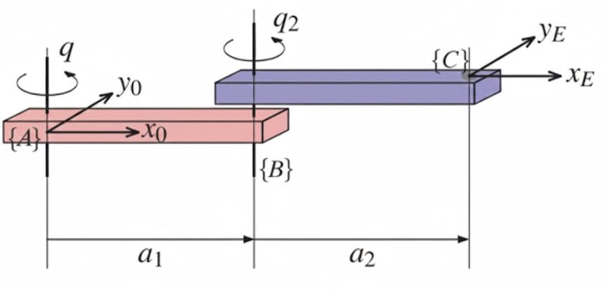
The position of second joint, i.e. where q2 rotates, and the position of the end-effector can be described and calculated by their homogeneous transformation matrices. The position of the first joint, i.e. where q1 rotates remains fixed. For example, the homogeneous transformation matrix can be used to find the coordinate of an arbitrary point P in coordinate of frame {A} from the perspective of frame {B} as follows:
$$P^{A}= T_{B}^{A}.P^{B}$$
$$\left(\begin{matrix}x^{A} \\ y^{A} \\ 1\end{matrix}\right)=\left(\begin{matrix}cosθ & -sinθ & t_{x} \\ sinθ & cosθ & t_{y} \\ 0 & 0 & 1\end{matrix}\right)\left(\begin{matrix}x^{B} \\ y^{B} \\ 1\end{matrix}\right)$$
If there are more than two frames involved, $P^{A}$ can be found by simply multiplying the homogeneous transformation matrices of frame(i-1) and frame(i) to obtain the final homogeneous transformation matrix. For example, if there is another frame C, $T_{C}^{A}= T_{B}^{A}.T_{C}^{B}$.

Part B (Inverse Kinematics)
Determine the joint angles $θ_{1}$and $θ_{2}$that allow the end effector to reach a given target point $(x_{target},y_{target})$.
Instead of using the closed-form solution, you will use a genetic algorithm to optimize the joint angles.
- Implement Genetic Algorithm in Java to search for the joint angles that minimize the error between the desired end effector position and the position computed by the forward kinematics.
- The fitness function should be the eucliden distance between the target and the computed position.
- Implement standard GA operators such as the type of selection (Roulette wheel or tournament selection), crossover (single-point or uniform crossover) or mutation (random perturbation of joint angles).
- Use object oriented approach and define relevant classes such as GeneticAlgorithm, 2DRobotArm etc.
- There must be one class to input a target position (x,y), run the GA, and output the joint angles found in each generation and its corresponding end effector position.
- Test your program on at least three different target positions with error less than 0.01 units from target.
- Write a report explaining your choice of GA parameters and discuss convergence behaviour. Include screenshots of your outputs showing the results for all test points. Submit both the report and your source code.
- Optional: using Javafx to show the animation of intermediate arm movements.

Submit your source code and report containing the UML diagram and the output via PutraBlast.

